* Check this : <https://www.vogella.com/tutorials/ApacheMaven/article.html>

**1. To import eclipse project into IntelliJ:**

File Open project.

Select an eclipse project

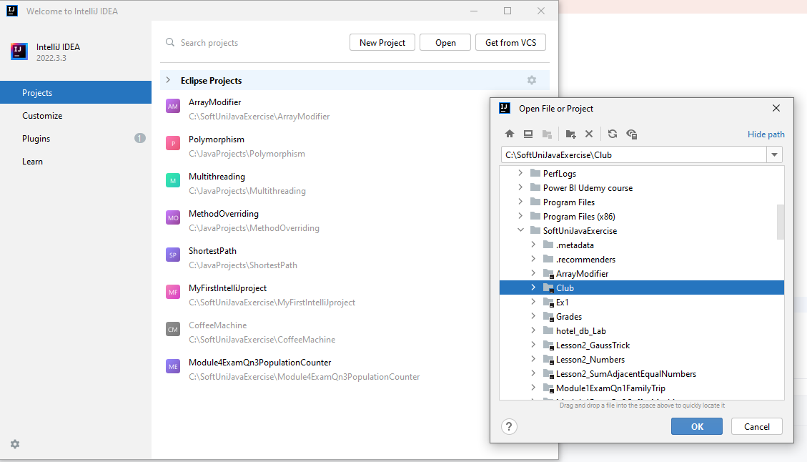

Press Ctrl+Shift+A (Search all)

Type Import Module from existing sources

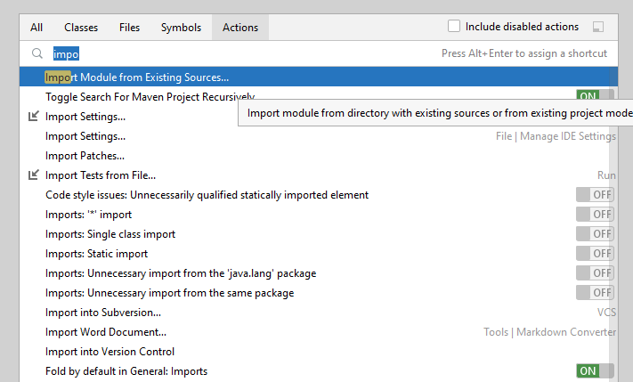

Press Ctrl+Shift+A (Search all)

Type Import Module from existing sources

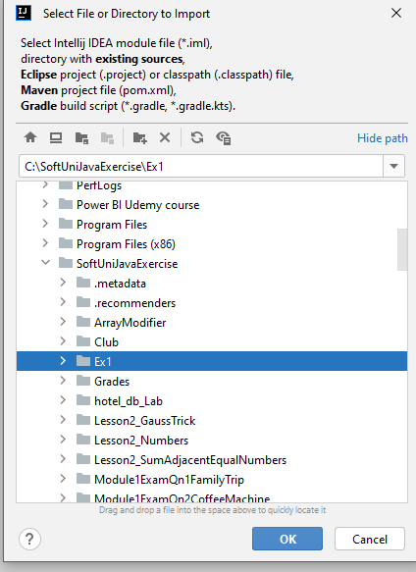

Select Import Module from external sources – Eclipse

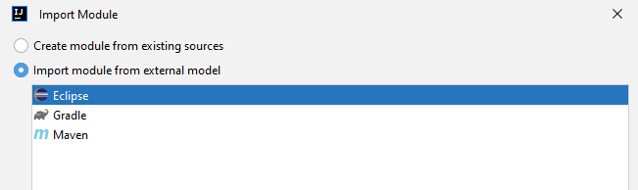

**2. To convert a non Maven project to Maven project:**

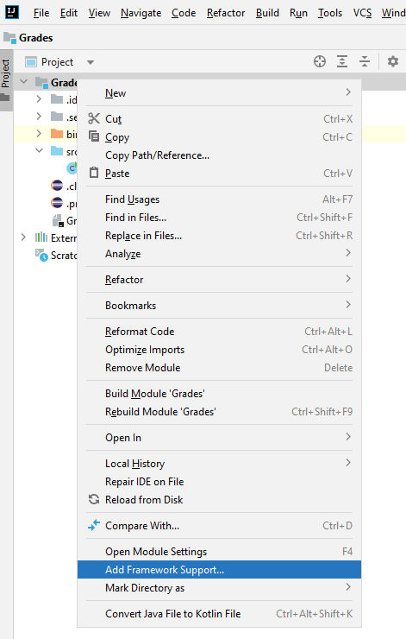

Choose Maven

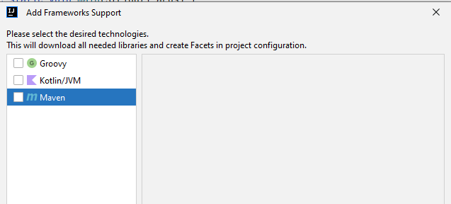

Maven tool window(View->Tool Windows)

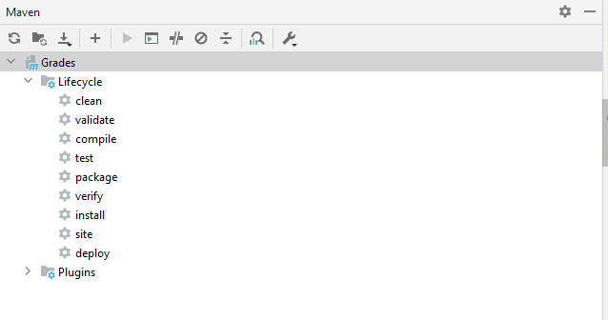

To generate Maven project from cmd line in interactive mode:

